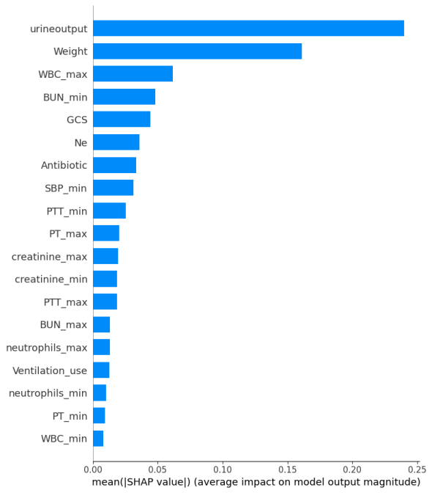

**Supplementary** **Figure 1a** SHAP value. Feature importance ranking

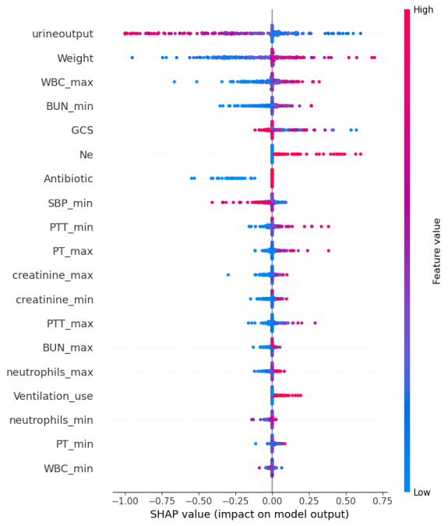

**Supplementary** **Figure 1b** Summary graph of SHAP values.(A SHAP value above 0 indicates an increased risk of AKI occurring, while a value below 0 indicates a reduced risk.)

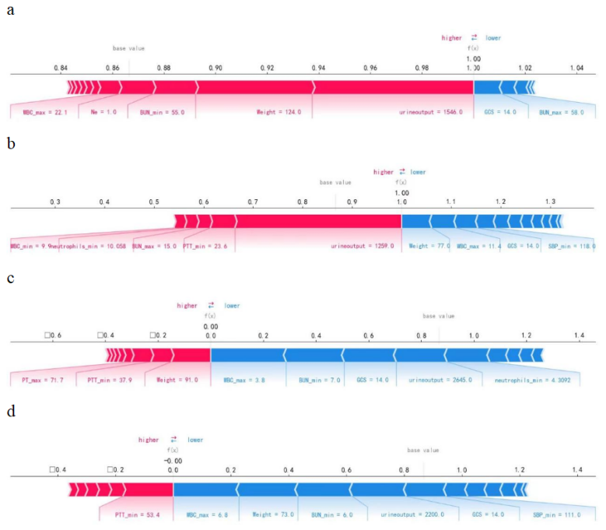

**Supplementary** **Figure 2** SHAP force plot analysis is utilized to interpret individual prediction outcomes. (Figures a and b illustrate cases where AKI occurred, while figures c and d depict cases where AKI did not occur. In the SHAP force plot, red and blue colors represent risk factors and protective factors, respectively. Feature importance is displayed by the length of the bars, where greater importance is indicated by longer bars.)